MEDIA RELEASE

Aurora Expeditions Named World’s Best Expedition Cruise Line

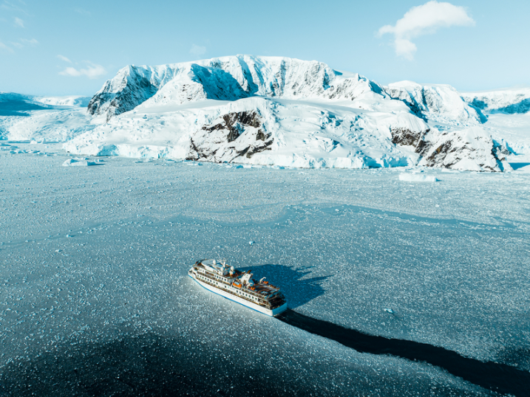

SYDNEY, AUSTRALIA, 16 October 2023 – Aurora Expeditions, the Australian-owned leading expedition travel company, has been named the ‘World’s Best Expedition Cruise Line’ at the prestigious 3rd annual World Cruise Awards, held in Dubai yesterday.

Established in 2021 as a sister event to the World Travel Awards, the World Cruise Awards recognises, rewards and celebrates excellence in the global cruise sector and its award categories are voted on by industry professionals, media and consumers.

“We are thrilled and honoured to receive this global award, only a few weeks ahead of commencing our exciting 2023-24 Antarctica season,” commented Aurora Expeditions’ Chief Marketing Officer, Hayley Peacock-Gower.

“As a small Australian-owned company with big ambitions in the expedition space, we are so proud to gain this recognition amongst our worthy fellow nominees, and we thank our expeditioners and travel industry peers who voted for us.

“Aurora Expeditions’ purpose is to create life-changing experiences in the world’s wildest places for our passengers, and to do so with the utmost respect for the environment and a positive impact.

From our purpose-built small ships and unique destinations to our highly knowledgeable Expedition Team who always follows the experience and not the itinerary, this award is a testament to our achievements thus far, as well as to our passionate and dedicated global team who sets the bar in expedition travel.”

For passengers looking to book their next adventure before October 31, the expedition company is currently offering some incredible deals across dozens of voyages on the soon-to-begin Antarctica season, as well as the Arctic & Global season for 2024, including air credits and no solo supplements.

For more information, visit www.aurora-expeditions.com
-END-
Media Contact
MMGY NJF
aurora@njfpr.com

Notes to Editors
Image credits: Aurora Expeditions, Tyson Mayr

About Aurora Expeditions
Aurora Expeditions is an award-winning, Australian-owned expedition company pioneering experiential travel for over 32 years. A pioneer in Polar Expeditions, Aurora is deeply committed to environmentally respectful travel to preserve the beauty and majesty that mother nature possesses, and we take real actions for the care of the planet.

Founded on the guiding principles of adventure and endless exploration, the small ship experience is intimate and friendly. Aurora Expeditions takes travellers on perspective-altering experiences to some of the planet’s most remote and incredible places.

Aurora’s two purpose-built ships, Greg Mortimer and our brand-new small expedition ship Sylvia Earle are designed for global discovery.

