MEDIA RELEASE

Aurora Expeditions gets connected with Starlink

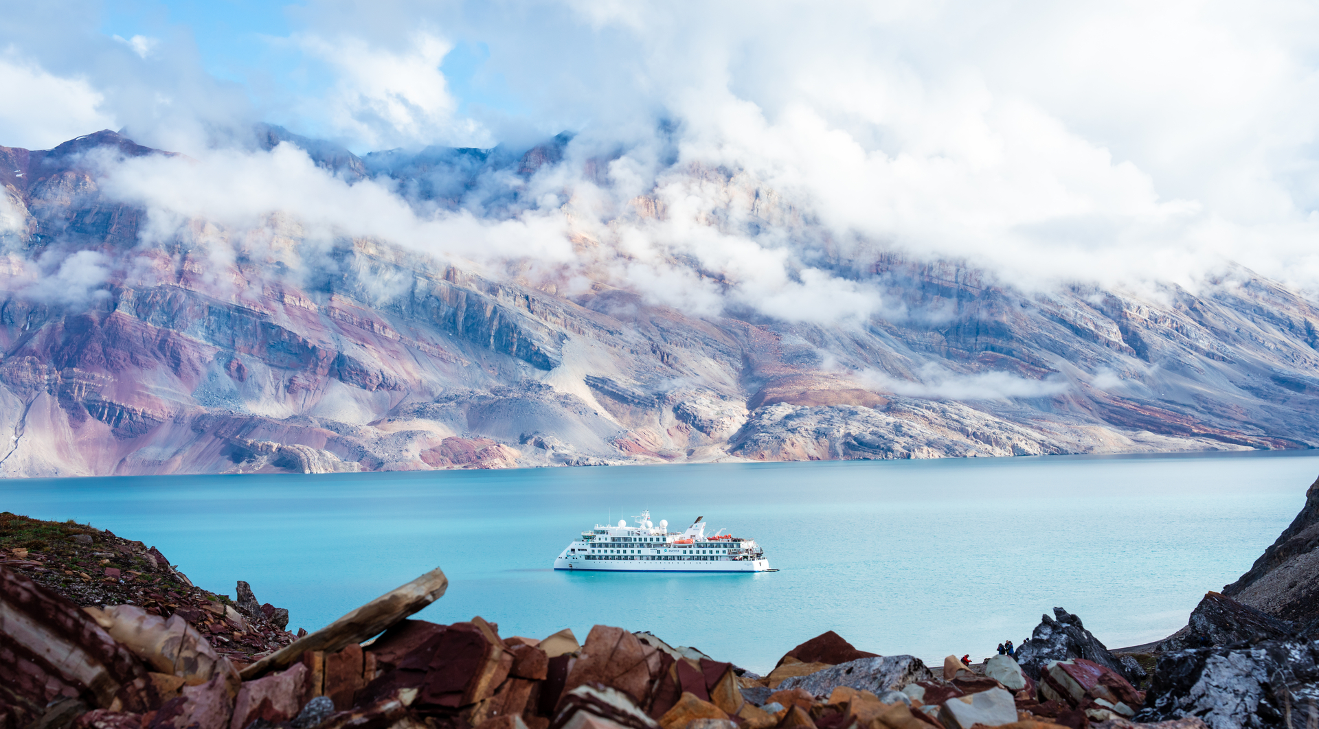

SYDNEY, AUSTRALIA, 10 October 2023 – Aurora Expeditions, Australia’s award-winning expedition travel company, has announced that its passengers will now enjoy enhanced onboard connectivity on its voyages, following the rollout of SpaceX’s Starlink aboard its purpose-built ships, the Greg Mortimer and Sylvia Earle.

The service has been implemented and is now available free of charge in all cabins and public spaces aboard the two vessels, allowing passengers to connect with friends and family at home, catch up with the news or their work even in the most remote environments.

“Reliable and high-speed internet connectivity in the cruise industry has traditionally been a challenge, particularly for expedition operators in places like Antarctica and the Arctic,” commented Michael Heath, CEO at Aurora Expeditions.

“Whilst our ships are designed to be a comfortable base camp for adventure and we encourage our passengers to get out and explore the natural environment as much as possible, we understand that staying connected is important to them. We’re thrilled to continue to offer cutting-edge technological innovations to meet the needs of our expeditioners, and we have already received incredibly positive feedback regarding the onboard experience.”

Aurora Expeditions offers life-changing voyages to some of the wildest and most remote destinations on the planet. For passengers looking to book their next adventure before October 31, the expedition company has some incredible offers to choose from across dozens of voyages, including air credits and no solo supplements.
For more information, visit www.aurora-expeditions.com
-END-
Media Contact
MMGY NJF
aurora@njfpr.com
Notes to Editors
Image credits: Aurora Expeditions, Tyson Mayr

About Aurora Expeditions
Aurora Expeditions is an award-winning, Australian-owned expedition company pioneering experiential travel for over 32 years. A pioneer in Polar Expeditions, Aurora is deeply committed to environmentally respectful travel to preserve the beauty and majesty that mother nature possesses, and we take real actions for the care of the planet.

Founded on the guiding principles of adventure and endless exploration, the small ship experience is intimate and friendly. Aurora Expeditions takes travellers on perspective-altering experiences to some of the planet’s most remote and incredible places.

Aurora’s two purpose-built ships, Greg Mortimer and our brand-new small expedition ship Sylvia Earle are designed for global discovery.

