MEDIA RELEASE

Aurora Expeditions announces Special Guest Program for 2023/24

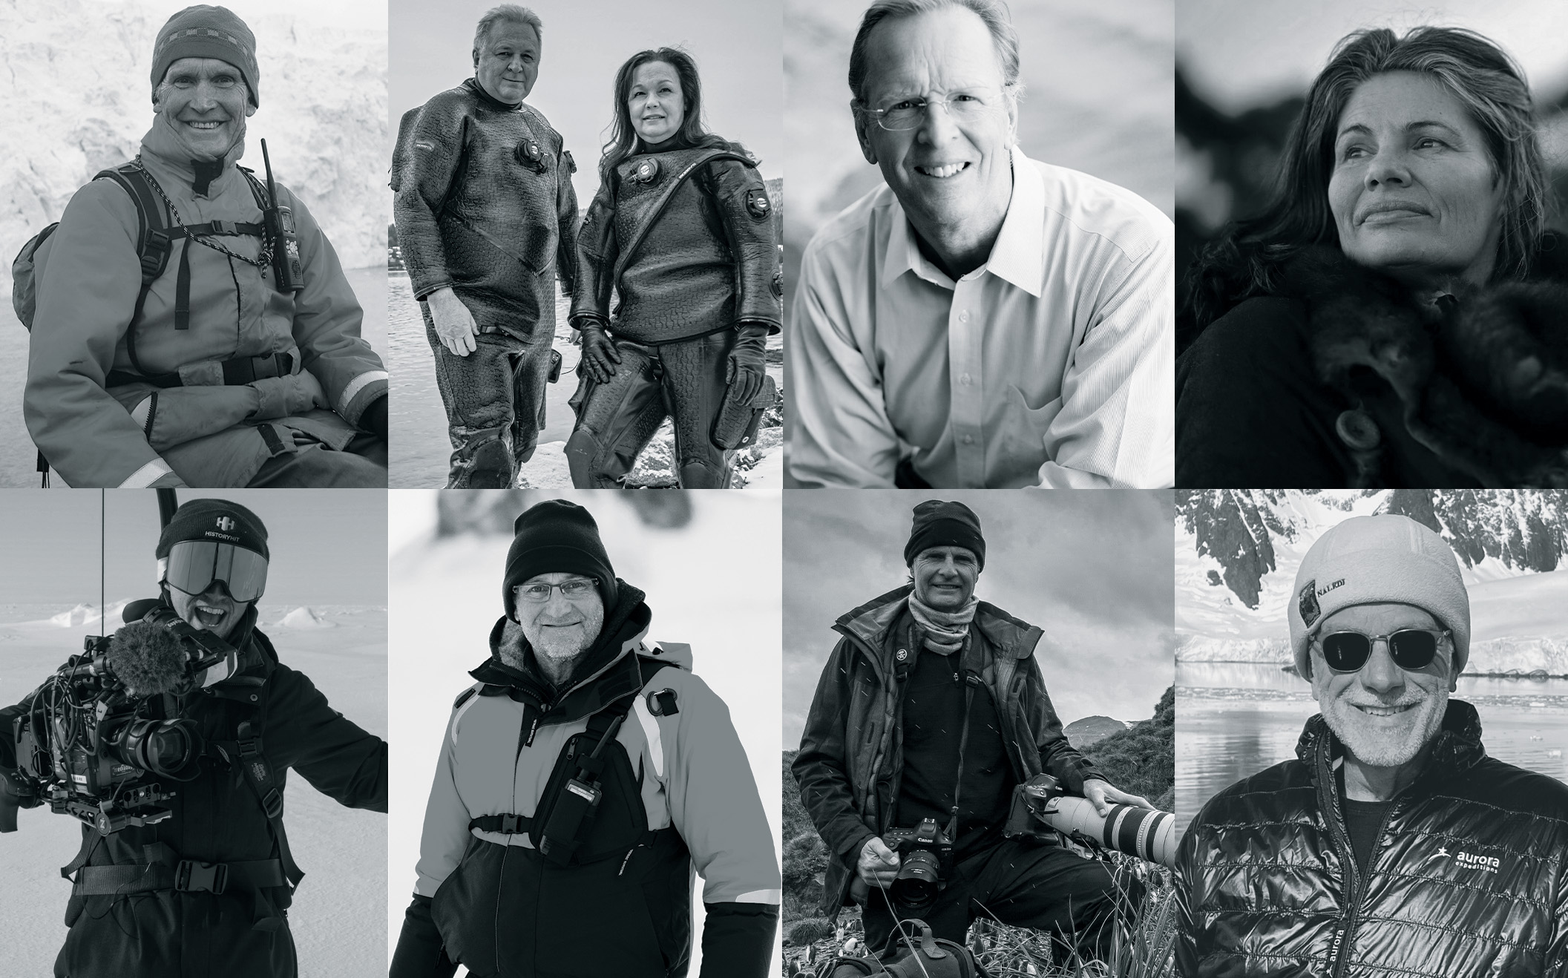

SYDNEY, AUSTRALIA (September 27, 2023) – Australia’s award-winning expedition company, Aurora Expeditions is proud to announce its Special Guests for its Antarctica 2023/24 season. Designed to enhance the passenger experience, the Special Guest program brings highly respected conservationists, adventurers, photographers and climate activists on a variety of voyages to share their expertise.

The program also includes the company’s second and third Founders voyages. Greg Mortimer OAM will lead the 23-day Antarctica Complete voyage on his namesake ship, departing Ushuaia on December 27, 2023. Passengers will ring in the new year with the pioneering adventurer, Zodiac cruising amongst the vast ice-covered landscapes of Antarctica and exploring enthralling subantarctic islands rich with history and unique wildlife.

Mortimer will also lead the 24-day Arctic Complete voyage in July 2024, travelling from Reykjavik to Longyearbyen for a complete exploration of the European Arctic’s west side, including the world’s largest fjord system in East Greenland. Expeditioners will spend their time scanning for whales, majestic polar bears and wallowing walrus on pack ice.
“People always ask me why I want to keep doing these trips time and time again,” commented Greg Mortimer.
“It’s simple – it’s never the same. From the chemistry of the people you travel with to the impact of the weather and the ice, and those things that come along that nature just throws at you. The chance encounters you can have on an expedition are wonderous.”
“Enrichment is a key component of the Aurora Expeditions experience,” commented CMO Hayley Peacock-Gower.

“Our renowned special guests inform and inspire our passengers, help to create deeper connections with the natural environments they visit, and have them leave the voyage with a richer understanding of our fragile planet.”

Additional special guests on the upcoming season include:

Gina Chick and Richard Morecroft

Gina Chick is a rewilding facilitator, adventurer, writer and speaker. Her rewilding programs help adults and kids learn to be at home in the wild, bringing hunter-gatherer techniques into the modern world.

Gina recently spent 67 days solo in the Tasmanian wilderness during the middle of winter, bringing only ten basic survival items and camera equipment to film her experiences. Gina’s determination, passion, and love of the natural world endeared her to more than 1.5 million people around Australia.

Gina will be interviewed on board by media personality, author and artist Richard Morecroft on the topic of connecting with wild environments.

Voyage: 21-day Falklands, South Georgia & Antarctic Peninsula, departing March 13, 2024

Saunders Carmichael Brown
Saunders Carmichael-Brown is an award-winning digital and broadcast presenter and producer with a background in adventure travel, sports and sustainability.
He was integral to the small media team on the 2022 Endurance Antarctic Expedition that found Sir Ernest Shackleton’s famous shipwreck. Saunders was fundamental in broadcasting the expedition journey and updates to millions of viewers across the world.
Voyage: 14-day Deep Weddell following Nordenskjöld, departing March 24, 2024.

Don Maruska
Don encourages people around the world to take climate action and to have fun while doing it. Since 2003, he has brought together people from scientific, environmental, business, government and community organisations to boost awareness, actions, and advocacy for stewardship of natural resources.

A Silicon Valley entrepreneur, Don now spends his time coaching and advising businesses and individuals as well as authoring many books including “How Great Decisions Get Made” and “Solve Climate Change Now: Do What You Love for a Healthy Planet”, which shares practical and fun ways to take action for a healthy climate.

Voyage: Join Don on the 12-day Spirit of Antarctica, departing December 11, 2023

Peter Eastway
Peter Eastway is an Australian photographer known internationally for his landscape and travel imagery. He was the author of the Lonely Planet’s Guide to Landscape Photography, and his photography has recently been featured on the cover of the Lonely Planet’s guide to Australia amongst several other prominent channels.
Peter has been involved in photographic magazine publishing for over 30 years, establishing his own title, Australia’s Better Photography Magazine, in 1995. It is now one of Australia’s leading photography magazines.
Voyages:
- 12-day Spirit of Antarctica, departing January 9, 2024
- 24-day South Georgia & Antarctic Odyssey, departing January 19, 2024, and stopping at the rarely visited South Sandwich Islands
Richard I’Anson
Richard is a freelance travel photographer and Canon Master who has captured incredible images of people and places around the world for more than 35 years. His work has been published worldwide, including five editions of Lonely Planet’s Guide to Travel Photography. Richard was featured in the television documentary Tales By Light (available on Netflix) and is a Travel Photography Scholarship Mentor for World Nomads.
Richard has won numerous awards over the course of his career but is most proud of gaining a Master of Photography and one gold bar from the Australian Institute of Professional Photography.
Voyages:
- 14-day Across the Antarctic Circle, departing 24 February 2024
- 15-day Costa Rica and The Panama Canal, departing 19 April 2024

Jett and Kathryn Britnell
Jett and Kathryn Britnell are professional underwater, wildlife and expedition photographers, scuba divers, internationally published writers, speakers, shark advocates, marine conservationists and intrepid explorers.

Together, they form a dynamic team of photojournalists, capturing the wonders of the underwater world. Their publishing credits include publications such as the Globe & Mail, Canadian Geographic and many more, whilst Jett’s photography has graced more than 50 magazine covers and counting.

Voyage: 18-day Circle and Weddell, departing 8 March 2024
For more information, visit www.aurora-expeditions.com
-END-
Media Contact
MMGY NJF
aurora@njfpr.com

Notes to Editors
Image credits: Supplied

About Aurora Expeditions
Aurora Expeditions is an award-winning, Australian-owned expedition company pioneering experiential travel for over 32 years. A pioneer in Polar Expeditions, Aurora is deeply committed to environmentally respectful travel to preserve the beauty and majesty that mother nature possesses, and we take real actions for the care of the planet.

Founded on the guiding principles of adventure and endless exploration, the small ship experience is intimate and friendly. Aurora Expeditions takes travellers on perspective-altering experiences to some of the planet’s most remote and incredible places.

Aurora’s two purpose-built ships, Greg Mortimer and our brand-new small expedition ship Sylvia Earle are designed for global discovery.

