MEDIA RELEASE
Aurora Expeditions announces ‘Choose Your Adventure’ sale

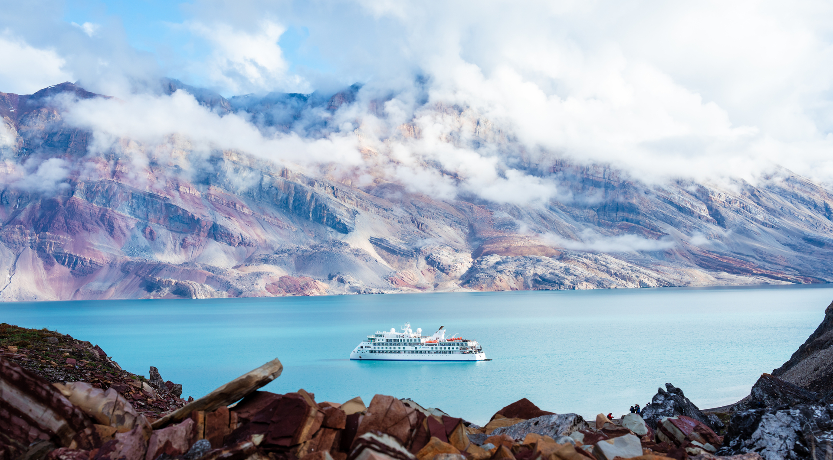

SYDNEY, AUSTRALIA (September 5, 2023) – Australia’s award-winning expedition company, Aurora Expeditions has today released two unprecedented offers as part of a ‘Choose Your Adventure’ sale for its upcoming seasons in Antarctica, the Arctic and beyond.

For a limited time, adventurous travelers can take advantage of Aurora’s most generous offers to date, including a USD$2,000 per person air credit for ALL Antarctica 23/24 and all Arctic & Global 24 season voyages. Solo travellers are also in luck with a no solo supplement offer for select Antarctica 23/24 and Arctic & Global 24 season voyages, in addition to generous savings of up to 20%*.

“We are thrilled to be offering some extraordinary savings for our upcoming voyages,” commented Aurora Expeditions’ CMO, Hayley Peacock-Gower.

“There are so many incredible, life-changing adventures for travelers to choose from, whether it be camping in Antarctica, rock climbing in Greenland, kayaking in Norway, or snorkeling in Costa Rica on their wish lists. We can’t wait to welcome our passengers on board to experience the Aurora difference with our small ships, expert teams, and commitment to responsible and respectful travel.”

The sale offers are valid across dozens of voyages on the company’s two purpose-built small expedition ships, the Greg Mortimer and the new Sylvia Earle, which was launched in late 2022. Offers are valid until October 31, 2023.

For more information and the full list of available voyages, visit https://www.aurora-expeditions.com/choose-your-adventure-sale/
*Terms & conditions apply
-END-
Media Contact
MMGY NJF
aurora@njfpr.com

Notes to Editors
Image credits: Aurora Expeditions/Tyson Mayr

About Aurora Expeditions
Aurora Expeditions is an award-winning, Australian-owned expedition company pioneering experiential travel for over 32 years. A pioneer in Polar Expeditions, Aurora is deeply committed to environmentally respectful travel to preserve the beauty and majesty that mother nature possesses, and we take real actions for the care of the planet.

Founded on the guiding principles of adventure and endless exploration, the small ship experience is intimate and friendly. Aurora Expeditions takes travellers on perspective-altering experiences to some of the planet’s most remote and incredible places.

Aurora’s two purpose-built ships, Greg Mortimer and our brand-new small expedition ship Sylvia Earle are designed for global discovery.

