MEDIA RELEASE

Capture the essence of the wild with Aurora Expeditions and WIN

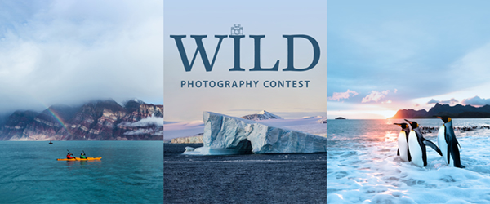

SYDNEY, AUSTRALIA, 19 August 2023 – In celebration of World Photography Day, expedition travel company Aurora Expeditions is calling all passionate photographers and adventurers to share their best images capturing the beauty and awe-inspiring wonders of the wild for the chance to win* a share of an AUD $10,000 prize pool.

Entrants can submit photos across three categories: Wild Souls, Wild Places or Wild Animals, to win one of four AUD $2,500 gift vouchers for photography equipment or accessories. The winners of the main categories will be decided by judges Richard I’Anson, Matt Horspool and Pia Harboure, three talented and award-winning photography experts and regular guides for Aurora Expeditions. A fourth ‘People’s Choice’ category will be decided by public vote.

Aurora Expeditions is a multi-award-winning expedition travel company with over 32 years of exploration experience, and a leader in life-changing, sustainable and respectful small-ship expeditions to the world’s most remote natural environments. Photography is one of many immersive and enriching experiences offered by Aurora, with an expert photography guide on board every voyage.

Running from August 19 to September 17, 2023, the Wild Photography Contest is open to anyone globally over the age of 18 years.
For more information, visit www.auroraexpeditions.com.au/2023-wild-photo-contest/
* Terms and conditions apply
-END-

For all media enquiries, please contact Svetlana Monastyrsky//
PR Manager
+ 61 452 604 514 e: svetlana@auroraexpeditions.com.au

Notes to Editors
Image credits: Aurora Expeditions

About Aurora Expeditions
Aurora Expeditions is an award-winning, Australian-owned expedition company pioneering experiential travel for over 32 years. A pioneer in Polar Expeditions, Aurora is deeply committed to environmentally respectful travel to preserve the beauty and majesty that mother nature possesses, and we take real actions for the care of the planet.

Founded on the guiding principles of adventure and endless exploration, the small ship experience is intimate and friendly. Aurora Expeditions takes travellers on perspective-altering experiences to some of the planet’s most remote and incredible places.

Aurora’s two purpose-built ships, Greg Mortimer and our brand-new small expedition ship Sylvia Earle are designed for global discovery.

For Asia Pacific enquiries
please contact Steve McLaughlin, Director of Sales – Asia Pacific
Email: smclaughlin@auroraexpeditions.com.au
Phone: +61 (2) 9252 1033
Mobile: +61 (0) 417 233 635

