MEDIA RELEASE
Unlock the Secrets of Two Destinations in One Adventure
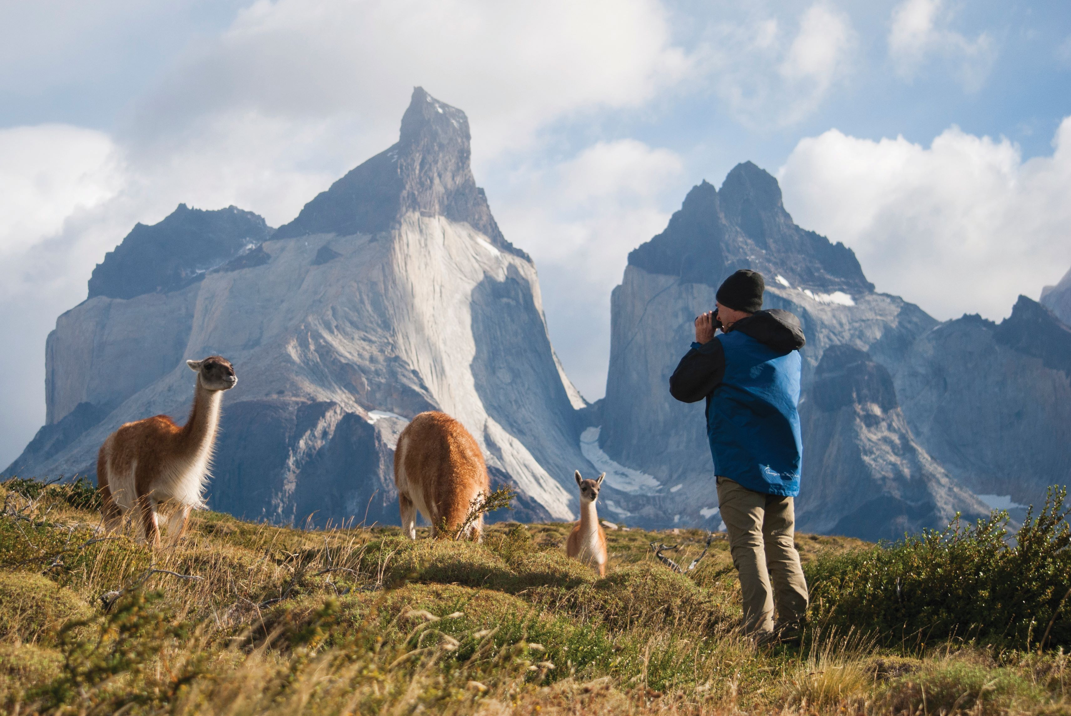

Aurora Expeditions is offering 50% saving on its Patagonia Discovery Trek when combined with an Antarctic 2023/24 voyage for a strictly limited time

SYDNEY, AUSTRALIA (July 06, 2023) – Award-winning Australian expedition company, Aurora Expeditions is offering travellers a journey of a lifetime when combining one of its Antarctic voyages with its awe-inspiring 10-day Patagonian Discovery Trek. When booked and deposited before September 30, 2023, adventurous travellers can save a generous 50%* off the cost of the immersive trek plus.

What’s more, several of these voyages departing from November 2023 to February 2024 are also offering up to an additional 25%* savings when booked and deposited before September 30, 2023, or until sold out. Passengers can also save an additional 5%* off the Antarctic voyage when combining the pre- or post-voyage with the Patagonian Discovery Trek.

Aurora Expeditions’ purpose-built, small ships, the Greg Mortimer and the Sylvia Earle, carrying an average of 132 passengers, serve as the perfect base camp for an Antarctic adventure as expeditioners discover its unforgettable icescapes and witness iconic wildlife. Travellers can select from six eligible voyage itineraries from the epic 24-day South Georgia & Antarctic Odyssey featuring the South Sandwich Islands, the popular Spirit of Antarctica or Antarctic Explorer to Aurora Expeditions’ shortest voyage, the 9-day Antarctic Explorer Express.

Extend the enthralling adventure by exploring the vast Patagonian wilderness on Aurora’s exceptional, guided Patagonia Discovery Trek, taking in two of Patagonia’s most iconic national parks and the famed Perito Moreno Glacier. Travellers should brace themselves for an unmatched adventure, hiking rugged trails overlooking iridescent blue glacial lakes, as Andean condors soar overhead among the towering ice-capped peaks.

The Patagonian Discovery Trek offers travellers three options enabling them to combine easily with an Aurora Expeditions Antarctic voyage. Choose between an Argentina return trip, an Argentina to Chile itinerary or a Chile to Argentina version. Use the graph below to assist with identifying the voyage departures that are combinable with the treks and narrow down that dream itinerary.

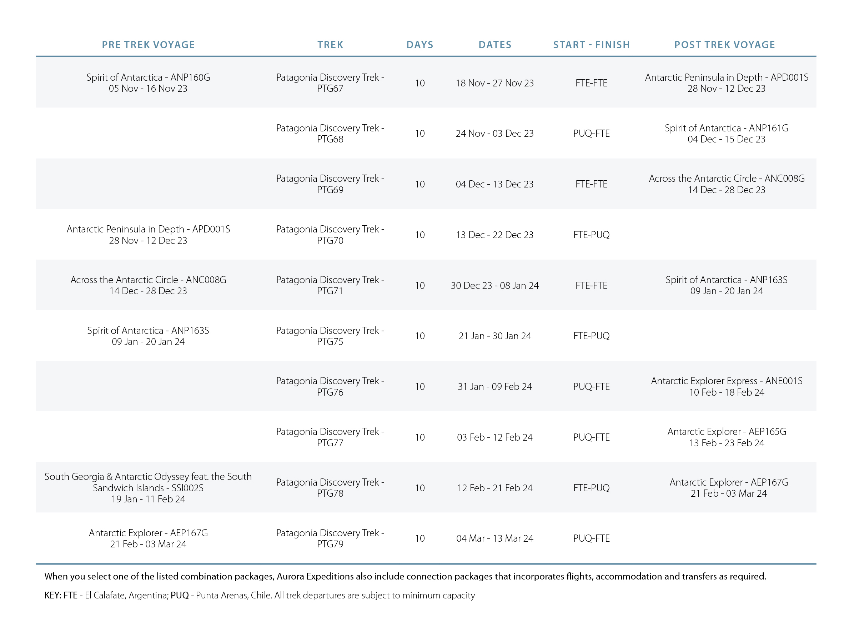
For more information, visit https://www.auroraexpeditions.com.au/land-and-sea-offer/
* Offers are subject to availability. Terms and conditions apply
-END-
For all media enquiries, please contact Virginia Haddon//
PR Manager
+ 61 414 275 839 e: virginia@auroraexpeditions.com.au

Notes to Editors
Image credits: Guancos – Torres del Paine, Chile – Lelia Cataldi
Please credit the listed photographers/Aurora Expeditions
https://library.aurora-expeditions.com/web/57827f158f94b7b7/patagonia-trek/

About Aurora Expeditions
Aurora Expeditions is an award-winning, Australian-owned expedition company pioneering experiential travel for over 32 years. A pioneer in Polar Expeditions, Aurora is deeply committed to environmentally respectful travel to preserve the beauty and majesty that mother nature possesses, and we take real actions for the care of the planet.

Founded on the guiding principles of adventure and endless exploration, the small ship experience is intimate and friendly. Aurora Expeditions takes travellers on perspective-altering experiences to some of the planet’s most remote and incredible places.

Aurora’s two purpose-built ships, Greg Mortimer and our brand-new small expedition ship Sylvia Earle are designed for global discovery. Our new ship is named after acclaimed marine biologist, oceanographer, explorer and conservationist Dr Sylvia Earle.

For Asia Pacific enquiries
please contact Steve McLaughlin, Director of Sales – Asia Pacific
Email: smclaughlin@auroraexpeditions.com.au
Phone: +61 (2) 9252 1033
Mobile: +61 (0) 417 233 635

