MEDIA RELEASE
AURORA EXPEDITIONS CLEANS UP FOR SARAH
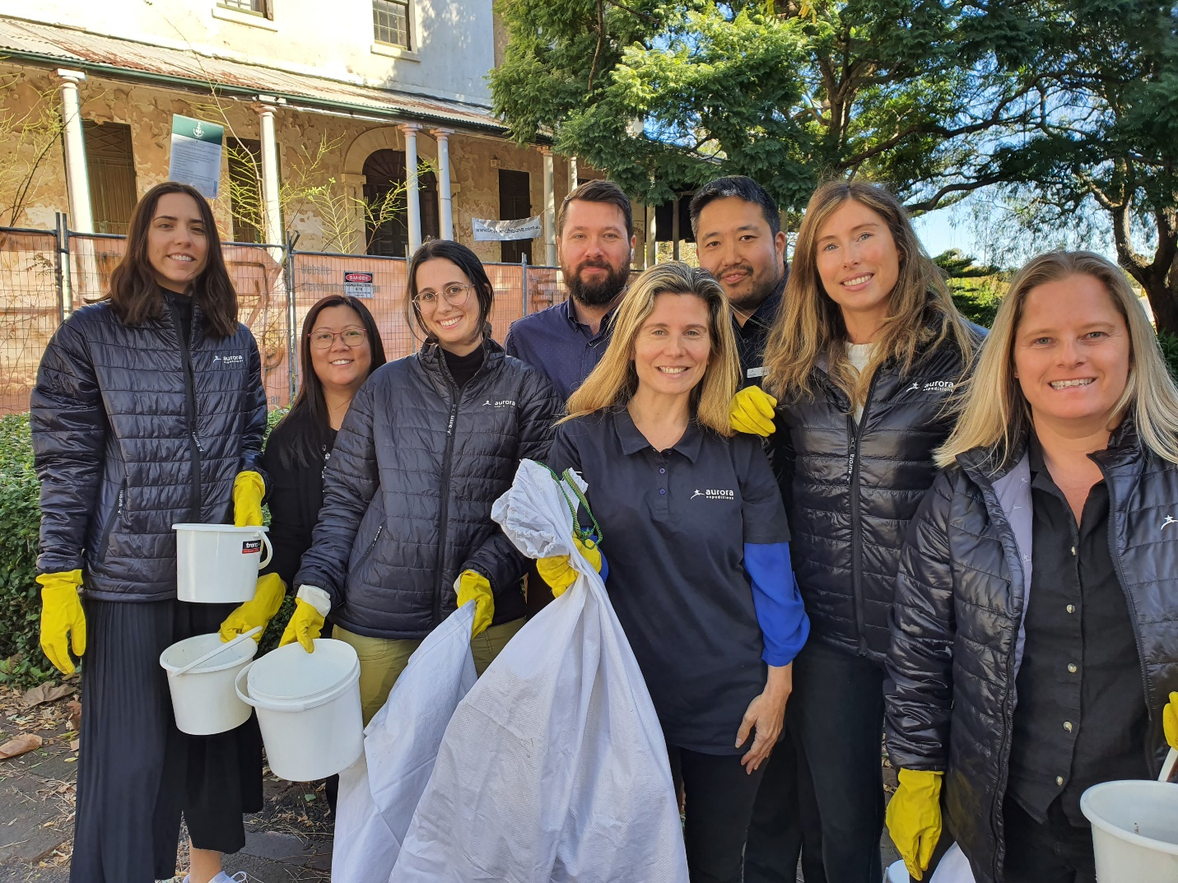

Sydney 14 June 2023 – The dedicated team from Aurora Expedition gave up their lunch hour to participate in the annual Clean Up for Sarah. This global initiative was established in 2019 through polar organisations AECO and IAATO in honour of Sarah Auffret who lost her life in an airline crash in March 2019 on her way to a Clean Seas project with the UN Environment Assembly.
Sarah was an environmental warrior, polar guide, expedition leader and Antarctic Base leader. She was instrumental in combating marine and single-use plastics in the expedition cruise market. This year marks the fifth year of the Clean Up for Sarah campaign with collecting from Asia and Europe to North America and Australia. The initiative happens every 14 June, Sarah’s birthday.
The Aurora Expeditions team collected over 11 kilograms of rubbish from a three blocks radius of its Surry Hills head office within a 40-minute timeframe.
Aurora Expeditions was founded more than 32 years ago on the guiding principles of discovery and exploration, with the utmost respect for the natural environments we visit. We see travel as a force for good, and we are committed to environmentally responsible travel and taking real actions for the care of the planet via our ever-evolving Sustainability In Action program. We aim to create ambassadors for the protection of the planet via our expedition education and enrichment programs, community engagement and strategic partnerships.

B Corp Certification is a natural progression as part of our overall Plan. Currently, we are in the Evaluation stage of Certification with expectations for this to be completed by the end of the year, 2023.
In addition to current initiatives and achievements, we have further goals, including delivering a global sustainable food program, working with regional producers who align with our passion for sustainable farming practices. In honour of our latest ship’s namesake, Dr Earle and her abiding commitment to ocean conservation, we have a dedicated Sustainable Sea Day on every Sylvia Earle voyage, eliminating seafood from the menu for that day.

Our portfolio of sustainability programs, actions and measures have the overarching goal of reducing negative impacts on the environment and communities and contributing to building a more sustainable world for future generations.

~ END ~

For all media enquiries, please contact Virginia Haddon// PR Manager
Phone: + 61 414 275 839 Email: virginia@auroraexpeditions.com.au

Photo credit: Aurora Expeditions
Front LtoR: Alex Fayan, Julie Robert and Katie Wills
Back LtoR: Hannah Charlton, Suzette Yu, Sasha Buch, Danyl Seledkov and Mark Go

About Aurora Expeditions
Aurora Expeditions is an award-winning, Australian-owned expedition company pioneering experiential travel for over 32 years. A pioneer in Polar Expeditions, Aurora is deeply committed to environmentally respectful travel to preserve the beauty and majesty that mother nature possesses, and we take real actions for the care of the planet.

Founded on the guiding principles of adventure and endless exploration, the small ship experience is intimate and friendly. Aurora Expeditions takes travellers on perspective-altering experiences to some of the planet’s most remote and incredible places.

Aurora’s two purpose-built ships, Greg Mortimer and our brand-new small expedition ship Sylvia Earle are designed for global discovery. Our new ship is named after acclaimed marine biologist, oceanographer, explorer and conservationist Dr Sylvia Earle.

