MEDIA ALERT

February 01, 2023

Greg, let me introduce you to Sylvia

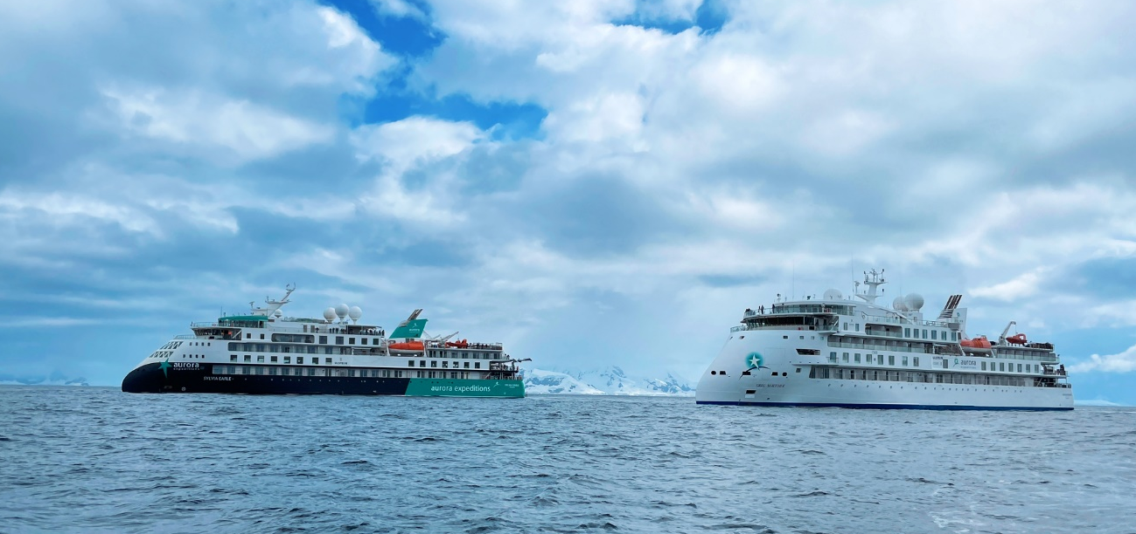

Aurora Expeditions’ two ships meet for the first time

Aurora Expeditions two ships met for the first time this week while in Antarctica, looking majestic in the icy landscape. The Greg Mortimer launched in 2019 has visited the region many times. The Sylvia Earle’s maiden voyage was in December 2022, and she recently departed on her fifth voyage in Antarctic waters.

Namesake, the world-renowned oceanographer Dr Sylvia Earle, will be christening her ship on February 15, 2023, before she departs on the inaugural Antarctic Climate Expedition, a nine-day voyage along with Ocean Geographic, Aurora Expeditions and a collection of renowned thought leaders.

Each of Aurora Expedition’s purpose-built, small ships takes an average of 132 passengers with an average of over 20 Expedition Team. Aurora was the first to use the ULSTEIN X-BOW® in a passenger ship. Its inverted bow design cuts through the swell minimising vibrations, enabling faster transits through sea passages and helping reduce fuel consumption. This, in combination with Rolls Royce dynamic stabilisers, offers unrivalled stability and comfort on ocean crossings.

With over 32 years of experience, Aurora Expeditions is founded on the guiding principles of endless exploration while travelling with the utmost consideration of the environment. Aurora is deeply committed to responsible, respectful and safe travel. We offer one of the highest Expedition Team-to-passenger ratios in expedition cruising. Their expertise brings to life the beauty and fragility of this spectacular polar region.

Aurora’s guide experience is imperative for ensuring passengers have a safe, fascinating, immersive and enjoyable expedition. Education and enrichment are also at the centre of our experience, our Expedition Team have always been about sharing their knowledge and insights so that our travellers leave richer than they did when they came onboard, ultimately creating lifelong ambassadors for the planet.

Travel agents can bring or send your clients to hear all about the ships at its Aurora live events in your neighbourhood: dates and locations listed here. Aurora can provide customized invites and ready-made marketing assets to assist with promotions here.

It’s also offering virtual client events on Friday 03 February at 11am (AEDT) or Wednesday 01 March at 3pm (AEDT).

Learn the Aurora difference as we feature our Bucket List for 2023.

###

For all media enquiries, please contact Virginia Haddon// PR Manager
Phone: + 61 414 275 839 Email: virginia@auroraexpeditions.com.au

Link to images here. Please credit the listed photographer.

Notes to Editors

About Aurora Expeditions
Aurora Expeditions is an award-winning, Australian-owned expedition company pioneering experiential travel for over 30 years. A pioneer in Polar Expeditions, Aurora is deeply committed to environmentally respectful travel to preserve the beauty and majesty that mother nature possesses, and we take real actions for the care of the planet.

Founded on the guiding principles of adventure and endless exploration, the small ship experience is intimate and friendly. Aurora Expeditions takes travellers on perspective-altering experiences to some of the most remote and incredible places on the planet.

Aurora’s two purpose-built ships, Greg Mortimer and our brand-new small expedition ship Sylvia Earle are designed for global discovery. Our new ship is named after acclaimed marine biologist, oceanographer, explorer and conservationist Dr Sylvia Earle.

