MEDIA RELEASE

Aurora Expeditions is proud of its inspirational women on International Women’s Day

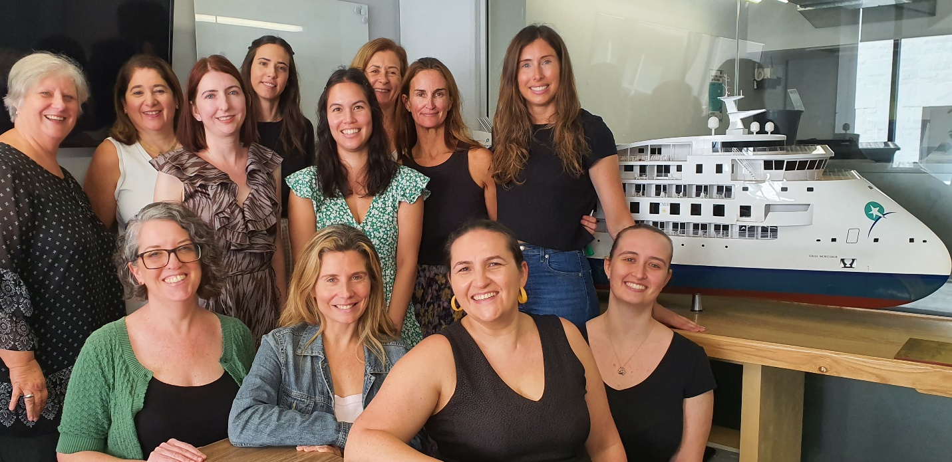

SYDNEY, AUSTRALIA (March 08, 2023) Award-winning, Australian-owned expedition company Aurora Expeditions, with over 32 years of history and purpose-driven exploration, prides itself on its innovative ways including its strong female influence. The organisation employs over 74 per cent of women, and 35 per cent of its Expedition Leaders are women.

Today, International Women’s Day, Aurora’s head office team (some pictured) will honour its strong, instrumental female employees with a presentation on their achievements followed by a morning tea.

Through its ground-breaking Women In Conservation program, and a world first, each of Aurora Expeditions’ newest ship, the Sylvia Earle, has its public decks named after six other pioneering female conservationists – Jo Ruxton (MBE), Sharon Kwok, Bernadette Demientieff, Dr Asha de Vos, Hanli Prinsloo and Australian Dr Carden Wallace (AM) – with a deck dedicated to Dr Earle herself.

Aurora Expeditions acknowledges female scientists are leading the way in global conservation initiatives and honours these seven extraordinary women who work tirelessly to make the world a better place. The scientists are inspiring leaders in their fields, and through the deck theming, will educate our expeditioners on the impressive and important conservation work they continue to do.

###

For all media enquiries, please contact Virginia Haddon// PR Manager
Phone: + 61 414 275 839 Email: virginia@auroraexpeditions.com.au

Photo credit: Aurora Expeditions
Front LtoR: Anna Jackson, Alex Fayan, Heidi Bullnough, Lucinda Lathlean
Back LtoR: Virginia Haddon, Lina Trimarchi, Oksana Prokopenko, Hannah Charlton, Alison Lo, Carolyn Wiseman, Hayley Peacock-Gower and Julie Robert.

Notes to Editors

About Aurora Expeditions
Aurora Expeditions is an award-winning, Australian-owned expedition company pioneering experiential travel for over 30 years. A pioneer in Polar Expeditions, Aurora is deeply committed to environmentally respectful travel to preserve the beauty and majesty that mother nature possesses, and we take real actions for the care of the planet.

Founded on the guiding principles of adventure and endless exploration, the small ship experience is intimate and friendly. Aurora Expeditions takes travellers on perspective-altering experiences to some of the most remote and incredible places on the planet.

Aurora’s two purpose-built ships, Greg Mortimer and our brand-new small expedition ship Sylvia Earle are designed for global discovery. Our new ship is named after acclaimed marine biologist, oceanographer, explorer and conservationist Dr Sylvia Earle.

