Aurora Expeditions Releases Inaugural Impact Report

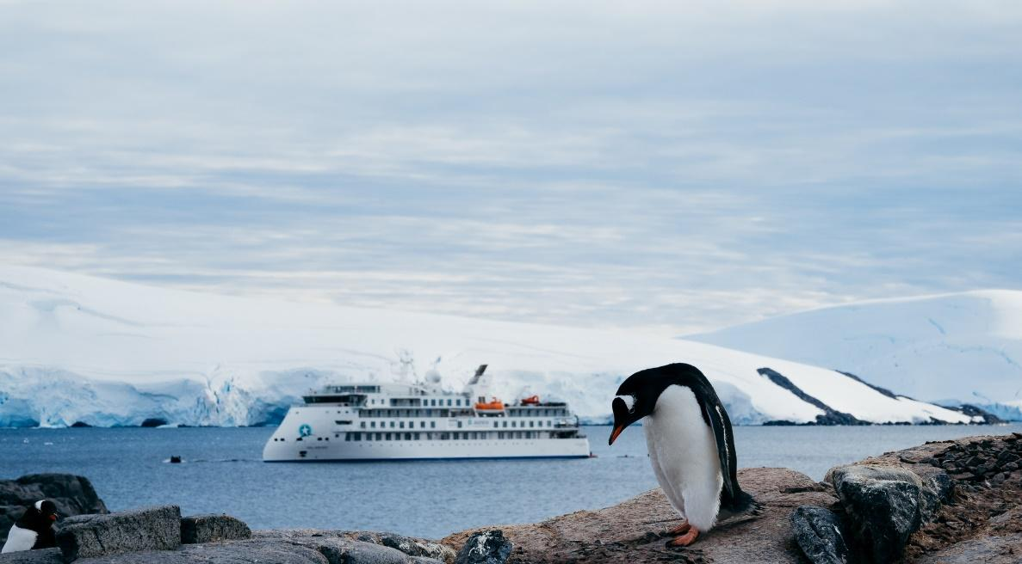

SYDNEY, AUSTRALIA – July 27, 2023 – Today, Australia’s leading expedition travel company, Aurora Expeditions, has released its inaugural Impact Report 2022-2023. Titled ‘Protecting the world’s wild places,’ it marks the first report of its kind for the expedition operator.

Founded 32 years ago on the guiding principles of discovery and exploration, Aurora takes passengers on expeditions to some of the world’s most fragile and untouched wilderness destinations. Recognizing its responsibility to protect these important ecosystems, this first Impact Report provides a comprehensive review of the company’s efforts to embed sustainable practices across all areas of the business to date, as well as its future goals.

“We are incredibly proud to release our first Impact Report, which outlines our commitment to sustainability and our vision to be the global leader in sustainable expedition travel,” commented Michael Heath, CEO of Aurora Expeditions. “This is about transparency and accountability for us as a business, and acknowledging where we are on our sustainability journey. We are acutely aware of the planet’s rapidly evolving climate crisis and the urgency with which we must all work together to help protect and regenerate our shared planet. Expedition travel holds a unique opportunity to educate and inspire people, which we believe is pivotal to safeguarding the wild and awe-inspiring places we visit.”

Aurora’s Impact Report reviews the company’s program of initiatives through the focus areas of ‘Planet’ and ‘People,’ including:

- Supporting seven of the UN’s Sustainable Development Goals (SDGs)
- 100% Climate Neutral status
- Emission reduction strategies, renewable energy and biodiversity conservation projects
- Reduction of plastics, water conservation and waste management practices
- A focus on education for passengers via onboard expert team and Citizen Science projects, honouring female conservationists onboard, and supporting access to climate change education for young people globally
- Collaboration with individuals and organisations who share the company’s vision, including Dr. Sylvia Earle and Ocean Geographic on leading projects such as the Antarctic Climate Expedition February 2023

B Corp Certification is a natural progression as part of Aurora’s overall plans and the company is currently in the evaluation stage of certification, with expectations for this to be completed by 2024.

Aurora’s portfolio of sustainability programs, actions and measures have the overarching goal of reducing negative impacts on the environment and communities, contributing to building a more sustainable world for future generations. This inaugural Impact Report acknowledges that the company’s emissions reduction is ongoing, committing to be part of the movement of innovative thought leaders and advocating for the development of new technology that makes the expedition cruise industry more sustainable.

To read the report, visit www.aurora-expeditions.com/impact-report

###
Photo credit: Gentoo Penguin, Jougla Point, Antarctica; Aurora Expeditions/Matt Horspool

About Aurora Expeditions
Aurora Expeditions is an award-winning, Australian-owned expedition company pioneering experiential travel for over 32 years. A pioneer in Polar Expeditions, Aurora is deeply committed to environmentally respectful travel to preserve the beauty and majesty that mother nature possesses, and we take real actions for the care of the planet.

Founded on the guiding principles of adventure and endless exploration, the small ship experience is intimate and friendly. Aurora Expeditions takes travelers on perspective-altering experiences to some of the planet’s most remote and incredible places.

Aurora’s two purpose-built ships, Greg Mortimer and our brand-new small expedition ship Sylvia Earle are designed for global discovery.

Media Contact
MMGY NJF
aurora@njfpr.com

