MEDIA RELEASE
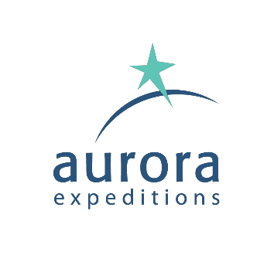
Are you thinking of heading north for the Summer?
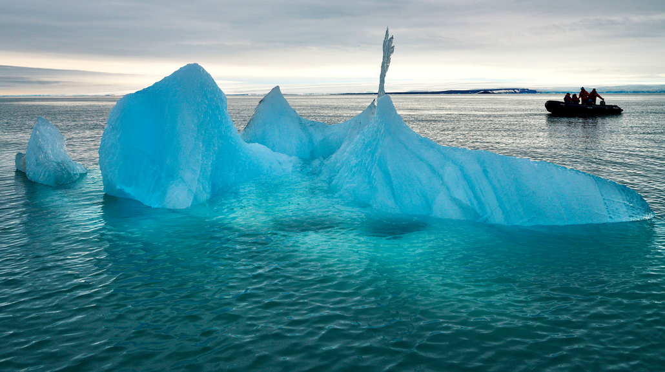
Now is the time to access limited-edition offers for Arctic 2023 sailings with Aurora Expeditions

SYDNEY, AUSTRALIA (May 03, 2023) – Aurora Expeditions is keen to showcase the mesmerizing beauty, enthralling history, and fascinating wildlife of the Arctic to as many travelers as possible. To help travelers access this region, Aurora is offering three savings opportunities for a strictly limited time, including flight credits of $1000 per person* for its Arctic 2023 sailings - a first for the leading Australian expedition travel company.

Solo travelers can travel without paying the regular single supplement* – a savings of 50 per cent of the full fare – on a range of departures. Solo travelers will enjoy a welcoming, relaxed environment on board Aurora’s purpose-built, intimate ships, the Greg Mortimer and the latest addition, the Sylvia Earle. They can immerse themselves in enlightening, life-changing adventures, on expeditions to fascinating locations such as the Arctic Circle, Greenland, Iceland, Svalbard, the Northwest Passage and even be dazzled by the Northern Lights.

Non-solo travelers do not miss out and can enjoy the savings Aurora is offering: up to 20 per cent* off all Arctic 2023 voyages.

Travelers will need to act fast to secure the best rates and best staterooms as there is strictly limited availability on these offers.

All three offers must be booked and deposited before June 30, 2023. The No Solo Supplement offer is not combinable with the other offers.

Multi-award-winning Aurora Expeditions, with its over 32 years of pioneering exploration, is focused on being the leader in life-changing, sustainable and respectful small-ship expeditions to the world’s most remote natural environments and through immersive and enriching experiences creating lifelong ambassadors of our planet.
For more information, visit www.auroraexpeditions.com.au.
* Offers are subject to availability. Terms and conditions apply
-END-
Solo Savings Departures:
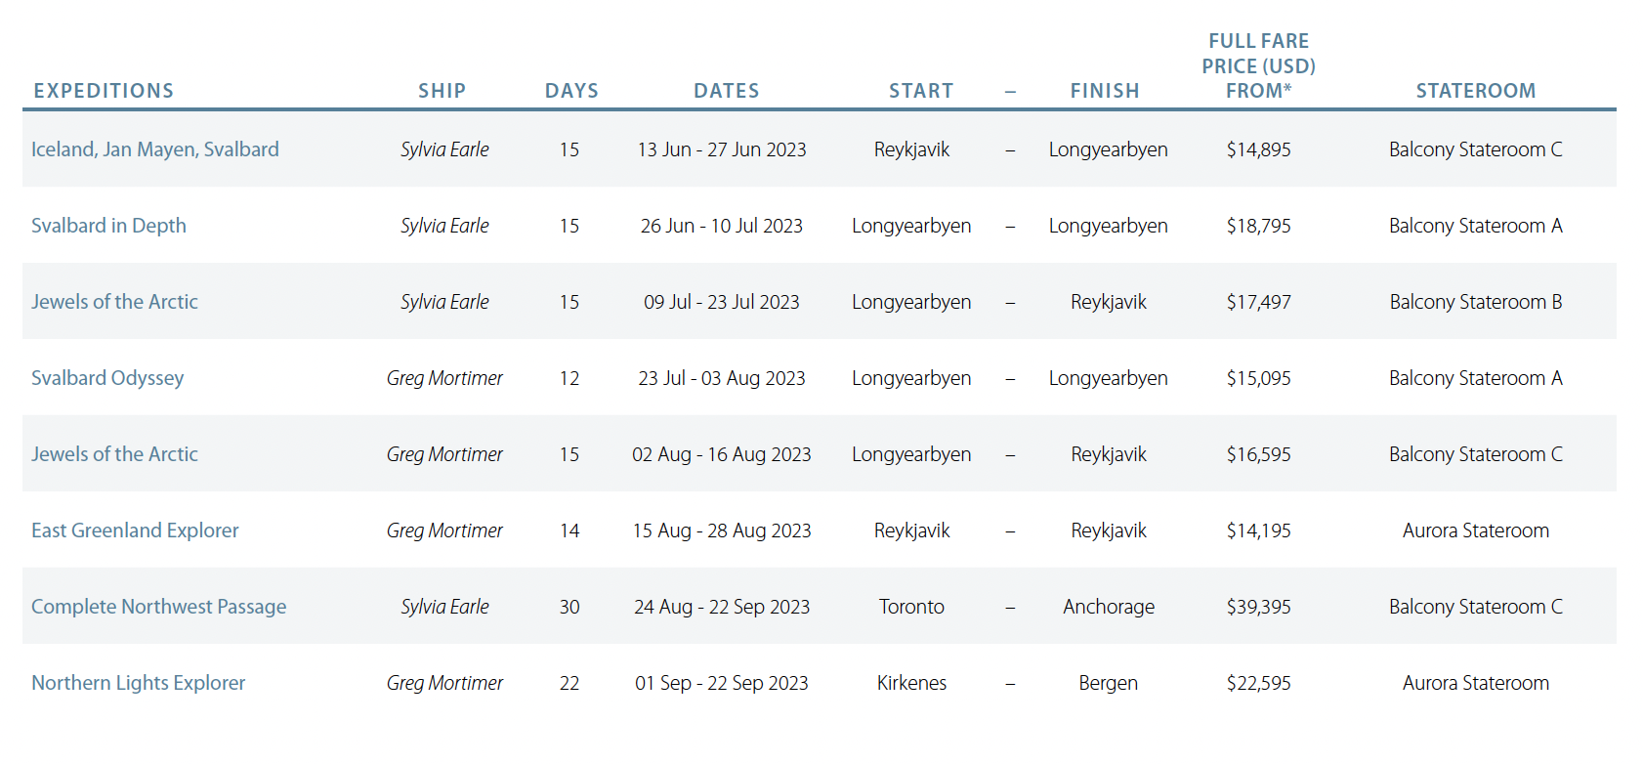
Notes to Editors
Image credits: Peter Eastway

About Aurora Expeditions
Aurora Expeditions is an award-winning, Australian-owned expedition company pioneering experiential travel for over 32 years. A pioneer in Polar Expeditions, Aurora is deeply committed to environmentally respectful travel to preserve the beauty and majesty that mother nature possesses, and we take real actions for the care of the planet.

Founded on the guiding principles of adventure and endless exploration, the small ship experience is intimate and friendly. Aurora Expeditions takes travelers on perspective-altering experiences to some of the planet’s most remote and incredible places.

Aurora’s two purpose-built ships, Greg Mortimer and our brand-new small expedition ship Sylvia Earle are designed for global discovery. Our new ship is named after acclaimed marine biologist, oceanographer, explorer and conservationist Dr Sylvia Earle.

For North American bookings & sales enquiries:
please contact Lisa Bertini, North American Director of Sales
Email: lbertini@aurora-expeditions.com
Phone: +1 (206) 235-1964

Media Contact:
MMGY NJF
aurora@njfpr.com

