MEDIA RELEASE
Are you thinking of heading north for the Summer?
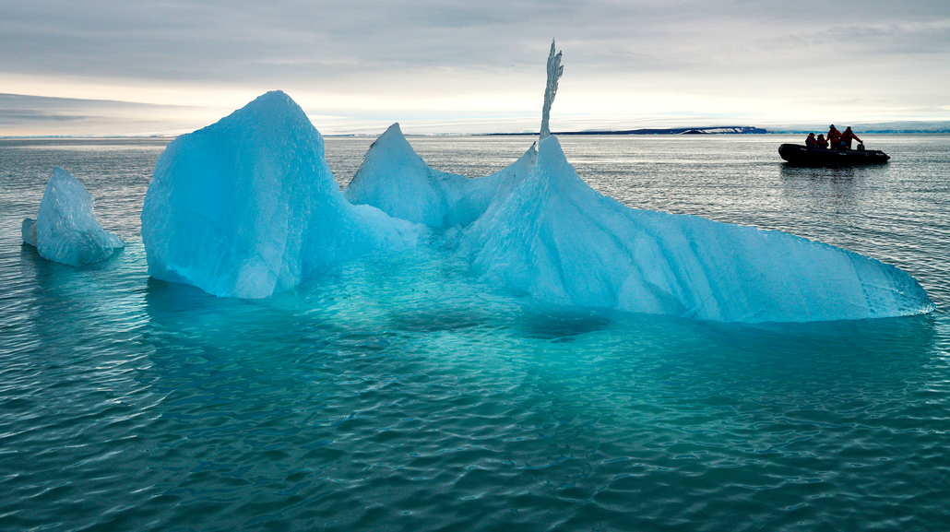
Now is the time to access limited-edition offers for Arctic 2023 sailings with AE Expeditions

SYDNEY, AUSTRALIA (May 02, 2023) – AE Expeditions (part of Aurora Expeditions) is keen to showcase the mesmerizing beauty, enthralling history, and fascinating wildlife of the Arctic to as many travellers as possible. To help travellers access this region, AE Expeditions is offering three savings opportunities for a strictly limited time, including flight credits of £1000 per person* for its Arctic 2023 sailings - a first for the leading Australian expedition travel company.

Solo travellers can travel without paying the regular single supplement* – a savings of 50 per cent on full fares– on a range of departures. Solo travellers will enjoy a welcoming, relaxed environment on board AE Expeditions’ purpose-built, intimate ships, the Greg Mortimer and the latest addition, the Sylvia Earle. They can immerse themselves in enlightening, life-changing adventures, on expeditions to fascinating locations such as the Arctic Circle, Greenland, Iceland, Svalbard, the Northwest Passage and even be dazzled by the Northern Lights.

Non-solo travellers do not miss out and can enjoy the savings AE Expeditions is offering: up to 20 per cent* off all Arctic 2023 voyages.

Travellers will need to act fast to secure the best rates and best staterooms as there is strictly limited availability on these offers.

All three offers must be booked and deposited before June 30, 2023. The No Solo Supplement offer is not combinable with the other offers.

Multi-award-winning AE Expeditions, with its over 32 years of pioneering exploration, is focused on being the leader in life-changing, sustainable and respectful small-ship expeditions to the world’s most remote natural environments and through immersive and enriching experiences creating lifelong ambassadors of our planet.
For more information, visit www.auroraexpeditions.com.au.
* Offers are subject to availability. Terms and conditions apply
-END-
Solo Savings Departures:
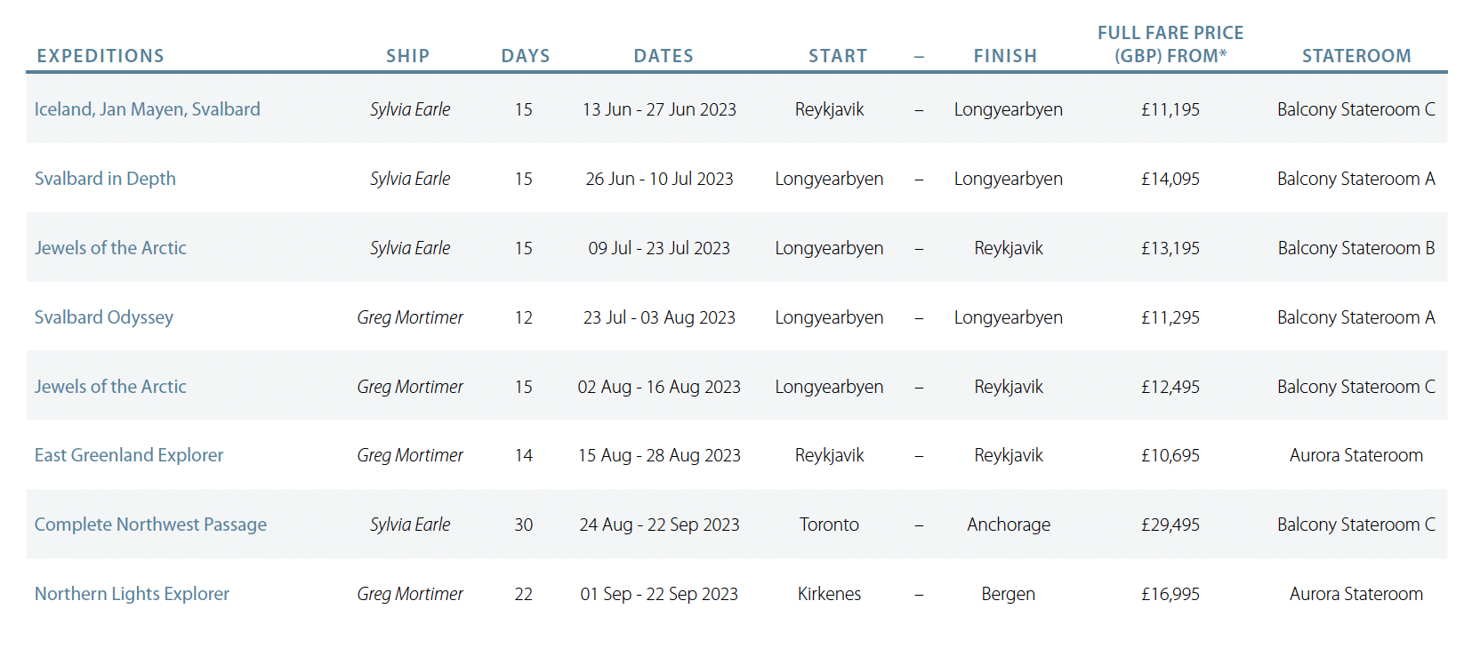
For all media enquiries, please contact:
Frangelica Flook // Cedar Tree Public Relations
Phone: + 44 (0) 7747 606 898 Email: frangelica.flook@cedartreepr.com

Notes to Editors
Image credits: Peter Eastway

About AE Expeditions

AE Expeditions is part of Aurora Expeditions headquartered in Sydney, Australia.

Aurora Expeditions is an award-winning, Australian-owned expedition company pioneering experiential travel for over 32 years. A pioneer in Polar Expeditions, Aurora is deeply committed to environmentally respectful travel to preserve the beauty and majesty that mother nature possesses, and we take real actions for the care of the planet.

Founded on the guiding principles of adventure and endless exploration, the small ship experience is intimate and friendly. Aurora Expeditions takes travellers on perspective-altering experiences to some of the most remote and incredible places on the planet.

Aurora’s two purpose-built ships, Greg Mortimer and our brand-new small expedition ship Sylvia Earle are designed for global discovery. Our new ship is named after acclaimed marine biologist, oceanographer, explorer and conservationist Dr Sylvia Earle.

For UK and Europe enquiries for the UK and Europe
please contact Jos Dewing, Managing Director – EMEA
Email: jdewing@auroraexpeditions.co.uk
Phone: +44 (0)7773 455 497

